**AVW ACCESS**

1. Open <http://asoc.it.att.com:8080/avs/av_home.xml>
2. Enter user’s ATTUID and password as abc , please refer below image:

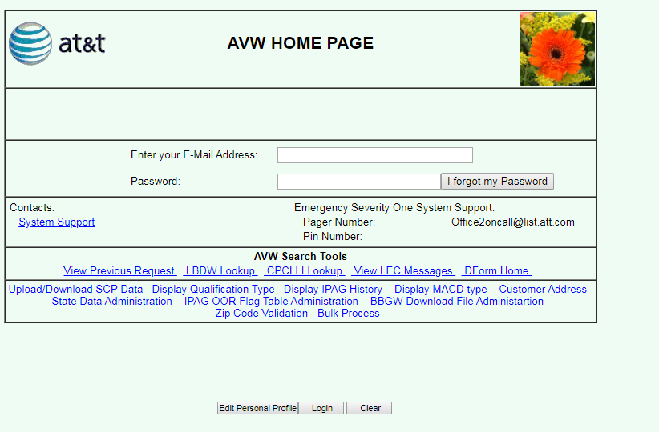

1. Click on login and pop up will appear saying “Are you a new user”, Click on yes.
2. On the next screen enter all the details. (Use webphone(<http://webphone.att.com/>) to get user info )

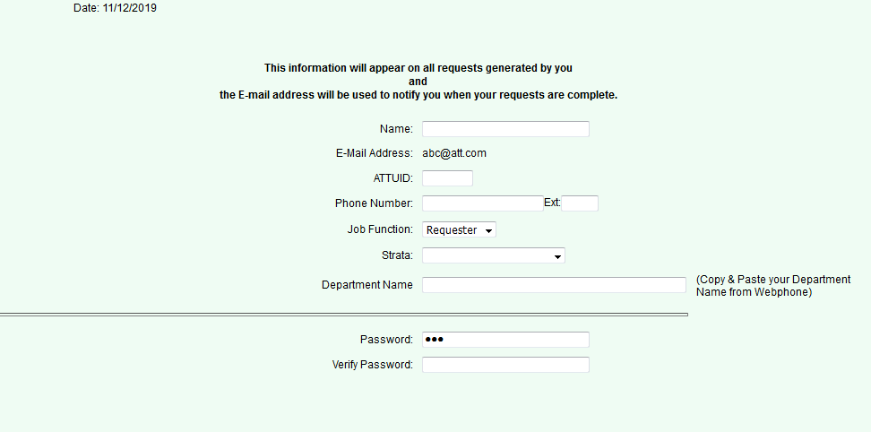

Note : Strata should be GLOBAL

1. After adding all info, click on ok.